I can complete 19 Activities in this guide to:

- Explain the abilities and limitations of chatbots like ChatGPT that aim to be informative.

- Compare and contrast the role of AI and humans in information-providing roles, such as an expert on a podcast.

19 Activities start now!
1/19 | ✏️Write your name:

2/19 | ✏️Your class period:

3/19 | 🔥Warm Up: What do you already know about ChatGPT?

4/19 | 💻Visit aiedu.org/ai-in-five to read the definition and interesting examples of AI.  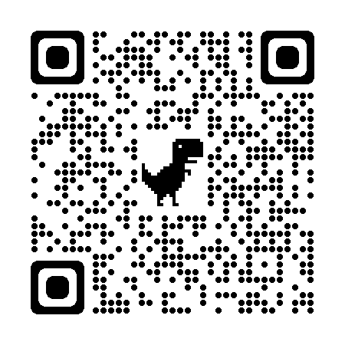  Scan the QR Code to visit AI in Five  🔗aiedu.org/ai-in-five

5/19 | 💻ChatGPT in action  ChatGPT can do a lot of things. It can act like a job interviewer, a football commentator, or a stand up comedian.  Let’s look at an example of ChatGPT in action:  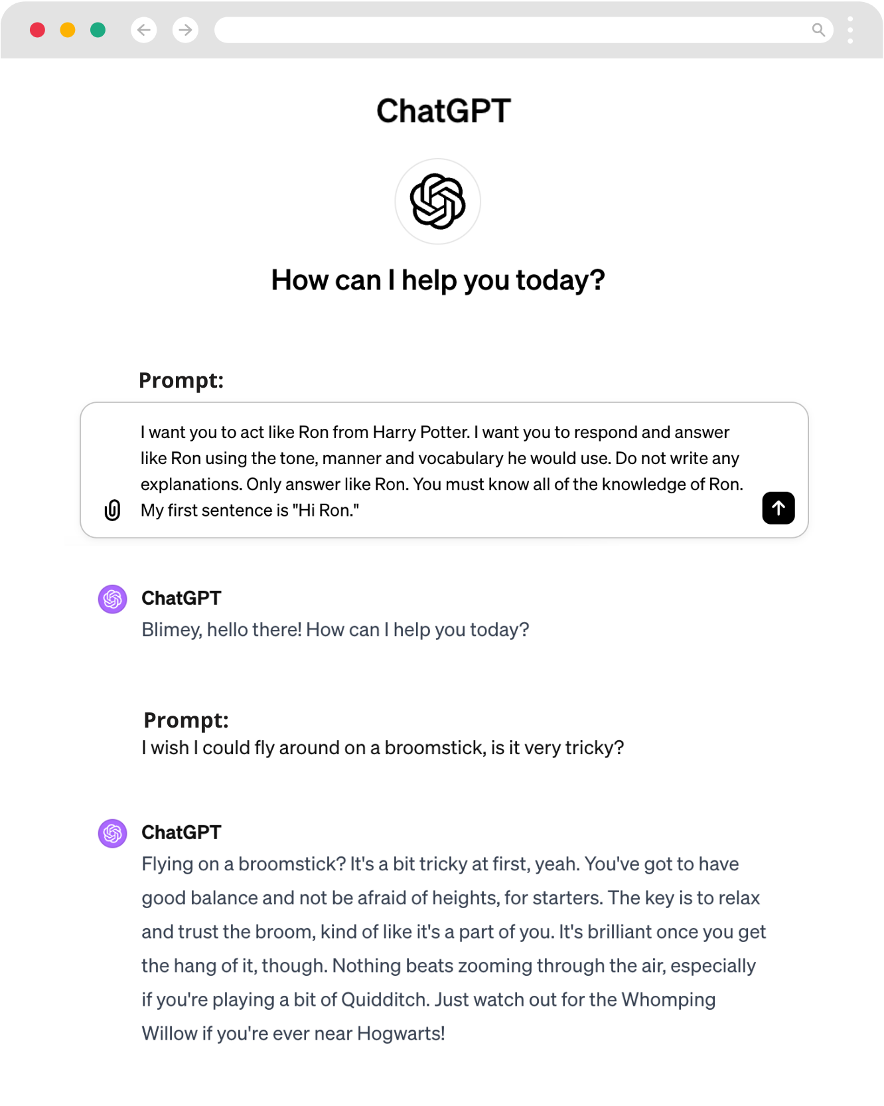

6/19 | ✏️How natural does ChatGPT sound and why? Write at least ONE (1) complete sentence in the space below.

7/19 | 🤖Try ChatGPT yourself  Your first task is to get familiar with ChatGPT. Test it thoroughly and figure out what it is and isn’t good at. You’ll be interviewing ChatGPT for your podcast later, so it’s important to know what it will and won’t respond well to.  STEP #1: Visit chat.openai.com to LOGIN or SIGN UP for a free ChatGPT account.  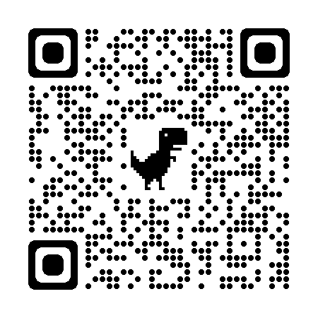  Scan the QR Code to visit ChatGPT  🔗chat.openai.com  ⚠️ChatGPT requires you to be 13 years or older to create an account. If you are under 18 you need permission from a parent or guardian.  STEP #2: Start a few new chats with ChatGPT and test out how it works.  Here are some ideas for what to chat with it about:  - Have a conversation with it as if it were your friend  - Ask it to explain something new to you  - Ask it for a top 10 list  - Write a poem or song lyrics with it  - Get some video game recommendations from it  - Ask it about itself  - Pretend to be a pirate and see how it reacts

8/19 | ✏️Which prompts did you try with ChatGPT?

9/19 | ✏️Who does ChatGPT sound like and why do you think that is?

10/19 | ✏️What do you think are ChatGPT’s strengths? List TWO (2) strengths:  1.  2.

11/19 | ✏️What do you think are ChatGPT’s weaknesses? List TWO (2) weaknesses:  1.  2.

12/19 | 🛑ChatGPT Safeguards  ChatGPT was created by OpenAI, an organization that focuses on developing and promoting friendly AI for the betterment of humanity.  OpenAI says that ChatGPT can’t answer 7 types of questions, including ones that:  - Require personal opinion or beliefs.  - Are illegal, unethical, or inappropriate.  - Require knowledge beyond my training data.  - Are impossible to answer with the available information.  - Involve speculation or conjecture without evidence.  - Ask for future predictions with complete certainty.  - Violate OpenAI's use-case policy."  ✏️Why do you think OpenAI created the policy that ChatGPT can’t answer these 7 types of questions? Do you agree with their decision?
🤿Diving Deeper (optional) Curious to learn more about the history of chatbots like ChatGPT? Use Google search to find the articles listed below.
- History of Chatbots by Codeacademy Team (Codeacademy, 2023)
- The Evolution Of Chatbots – From Origin To Conversational AI (Floatbot, 2022)

13/19 | 🎤Podcast Project  With a partner, you will create a podcast interviewing ChatGPT. When you record the podcast, one person will act as the host by reading the questions you come up with. The other person will pretend to be a person, but will actually be reading the responses from ChatGPT!  Follow these steps to write your podcast script:  - Choose a type of person you’d love to interview, like a Minecraft streamer, scientist, makeup vlogger, or politician.  - Write a set of interview questions you’d love to ask that person.  - Start a new chat with ChatGPT and prompt it by telling it who you want it to act as.  - Ask ChatGPT your questions as if you’re interviewing a real person.  - Write the intro and outro scripts so you know how you’ll introduce the interview and reflect on ChatGPT.  - Move on to the last section to record your podcast!  Podcast suggestions  - Write a short quiz segment where you ask ChatGPT true/false questions like “True or false: Runescape was created in 2007.”  - Give your podcast a fun name.  - Make sure you introduce your guest as a real person.

14/19 | ✏️Our interviewee (this is the character that ChatGPT will act as):

15/19 | ✏️Write at least SIX (6) interview questions:  1.  2.  3.  4.  5.  6.

16/19 | ✏️Our intro and outro script (what will you say to introduce the interview and share your reflection at the end):  Intro script:  Outro script:

17/19 | ⏯️Record your podcast  Great work writing your podcast script! In this section, you’ll set up your account with Spotify and record your podcast.  Follow these steps to record your podcast:  - Go to podcasters.spotify.com or download the mobile app “Spotify for Podcasters.” LOGIN or or SIGN UP to get started.  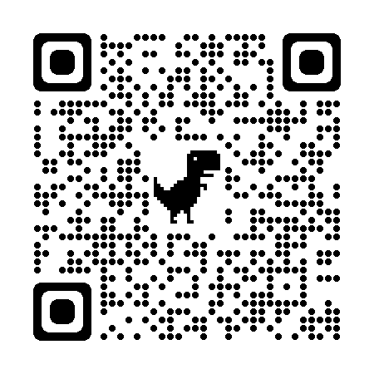  Scan the QR Code to visit Spotify for Podcasters  🔗podcasters.spotify.com  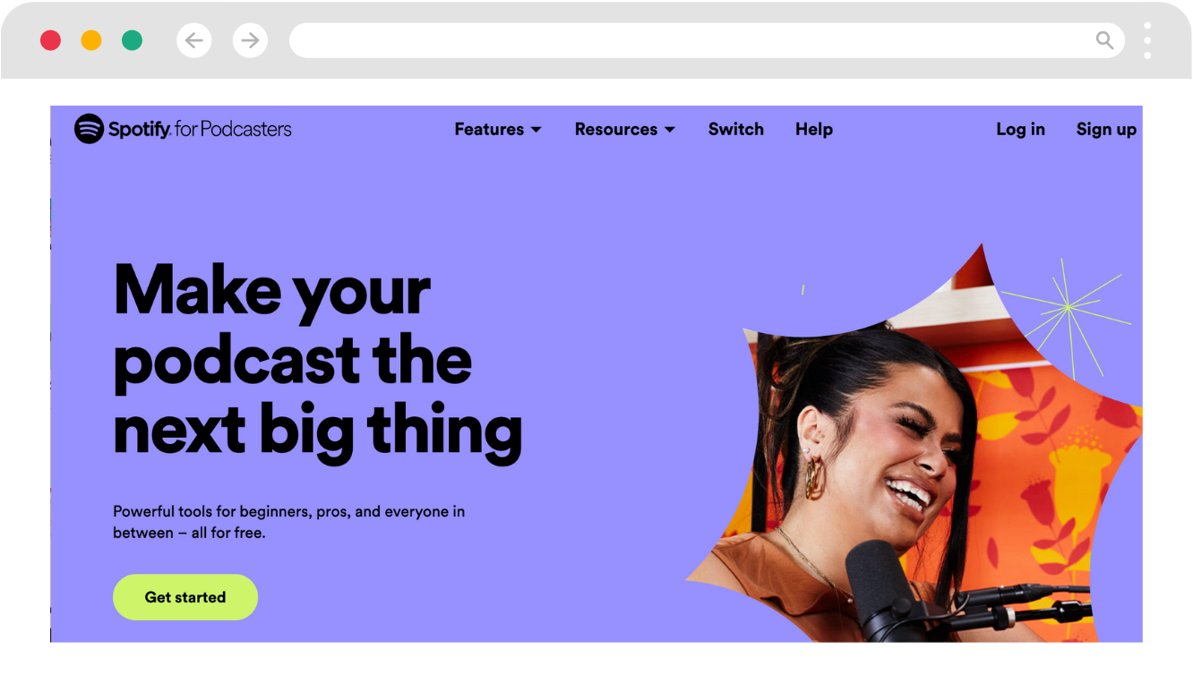  - Follow along with this step-by-step video tutorial to see how you can create a podcast.  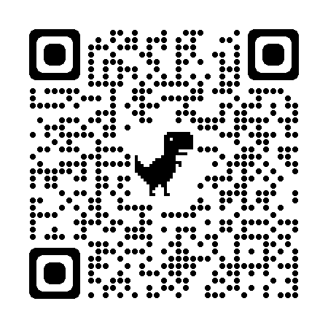  Scan the QR Code to visit the step-by-step video tutorial  🔗youtu.be/WRWSTXvrv48  - Fill in your Podcast settings to give your podcast a name and cover art  - Create a new episode  - Record clips of your intro, questions and answers, and outro reflection  - Add transitions or music  - Give your episode a name and description  - Publish your podcast and share the Spotify link with friends and family!
🦾Additional Podcast Resources:

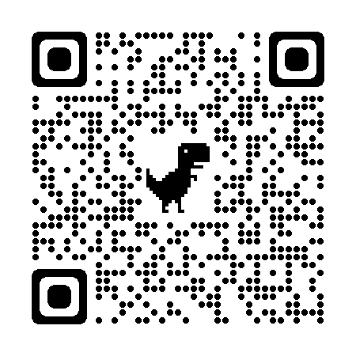  Scan the QR Code to visit Creating an Episode Guide | 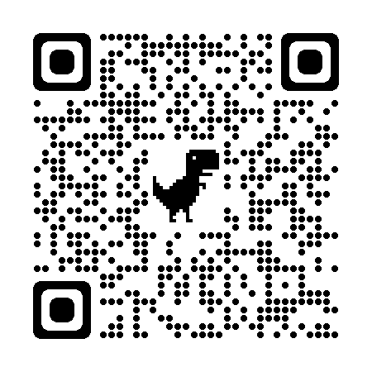  Scan the QR Code to visit How to Start a Podcast Guide | 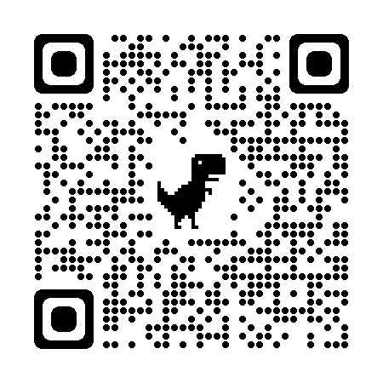  Scan the QR Code to visit Podcast Tips and Tricks by Spotify

18/19 | ✏️Reflecting on the podcast activity, can you recall an instance where ChatGPT's response didn't meet your expectations or seemed limited?
Not sure? Try these sentence starters:
- "When I asked ChatGPT about..., it was surprising that..."
- "ChatGPT didn't fully answer my question on..., which shows..."
- "I found it interesting that ChatGPT's response to... was..."
- "A moment that stood out was when ChatGPT couldn't explain..., suggesting..."
- "It was unexpected when ChatGPT responded to... with..."

19/19 | ✏️What are the main differences you noticed between how ChatGPT shares information compared to how a person does it?
Not sure? Try these sentence starters:
- "I saw that ChatGPT compared to a person is different because..."
- "A person gives information differently than ChatGPT since..."
- "Unlike a human, ChatGPT tends to..."
- "The way ChatGPT explained... was not like how a person would, because..."
- "ChatGPT's way of sharing info on... differed from a human's way in that..."

